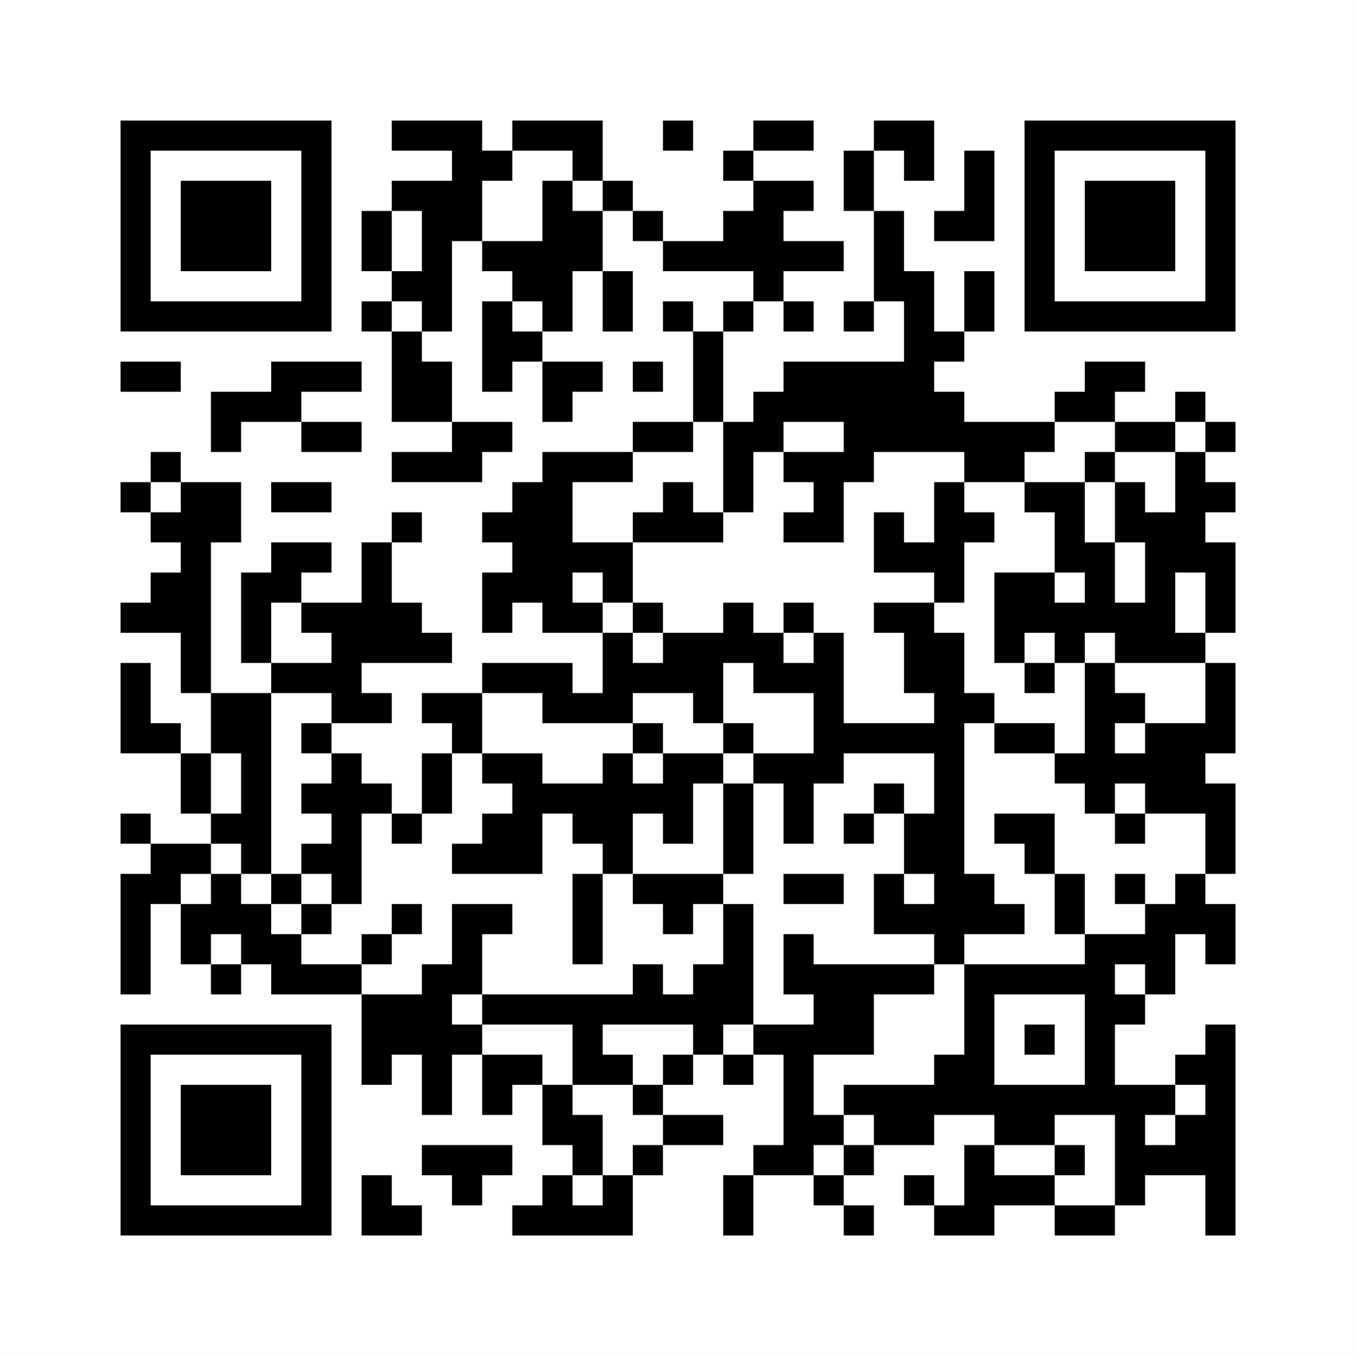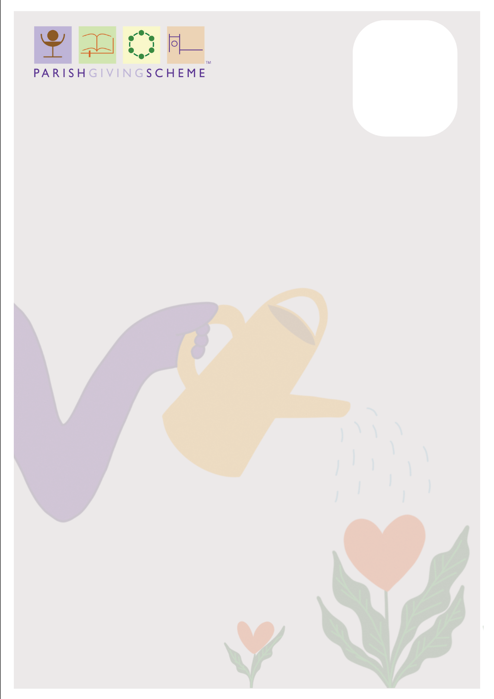

**Thank you for considering this option in your support of St James the Great.**

* The simplest way is online. Visit www.parishgiving.org.uk/donors/find-your-parish/radley-st-james-abingdon/ or scan the QR code on this sheet
* By phone: 0333 002 1271, Monday to Friday 9.00am-5.00pm
* By post using the application form provided in your envelope

You will need your bank details to set up the Direct Debit and, for phone or postal applications, St James the Great’s unique parish code 270627313.

**Thank you for considering this option in your support of St James the Great.**

You will need your bank details to set up the Direct Debit and, for phone or postal applications, St James the Great’s unique parish code 270627313.

* The simplest way is online. Visit www.parishgiving.org.uk/donors/find-your-parish/radley-st-james-abingdon/ or scan the QR code on this sheet
* By phone: 0333 002 1271, Monday to Friday 9.00am-5.00pm
* By post using the application form provided in your envelope

**The Parish Giving Scheme (PGS)** is a secure and simple way of giving to **St James the Great** on a regular monthly basis (or quarterly or annually if you prefer). It works by making a Direct Debit from your bank account on the 1st of the month, which is credited to our parish bank account by the 10th of the month. If eligible, you can opt to add Gift Aid and PGS claims this on our behalf, passing it back to St James the Great which benefits our cash flow.

It is also possible to make a one-off gift online and add Gift Aid if you are eligible. Instead of setting up a new Direct Debit, you use a debit or credit card, Apple Pay or Google Pay. Scan the QR code to get started.

If you opt to increase your gift annually, PGS will write to you and advise you of the new amount. If this is acceptable you don’t need to do anything, but you can choose to add more or to decrease the amount if you wish. If the majority of our planned givers were to opt for this, it would have a huge impact on our finances. Like many churches, one of the problems we face is that of ‘static giving’, often through inertia rather than intention.

It is also possible to make a one-off gift online and add Gift Aid if you are eligible. Instead of setting up a new Direct Debit, you use a debit or credit card, Apple Pay or Google Pay. Scan the QR code to get started.

If you opt to increase your gift annually, PGS will write to you and advise you of the new amount. If this is acceptable you don’t need to do anything, but you can choose to add more or to decrease the amount if you wish. If the majority of our planned givers were to opt for this, it would have a huge impact on our finances. Like many churches, one of the problems we face is that of ‘static giving’, often through inertia rather than intention.

**The Parish Giving Scheme (PGS)** is a secure and simple way of giving to **St James the Great** on a regular monthly basis (or quarterly or annually if you prefer). It works by making a Direct Debit from your bank account on the 1st of the month, which is credited to our parish bank account by the 10th of the month. If eligible, you can opt to add Gift Aid and PGS claims this on our behalf, passing it back to St James the Great which benefits our cash flow.