Compline in Traditional Language

The ancient office of Compline derives its name from a Latin word meaning 'completion' (completorium). It is above all a service of quietness and reflection before rest at the end of the day. It is most effective when the ending is indeed an ending, without additions, conversation or noise. If the service is in church, those present depart in silence; if at home, they go quietly to bed.

Preparation

The Lord almighty grant us a quiet night and a perfect end.
All Amen.

Be sober, be vigilant; because your adversary the devil,
as a roaring lion, walketh about, seeking whom he may devour:
whom resist, steadfast in the faith.
1 Peter 5.8,9
But thou, O Lord, have mercy upon us.
All Thanks be to God.

Our help is in the name of the Lord
All who hath made heaven and earth.

A period of silence for reflection on the past day may follow.

All We confess to God almighty,
the Father, the Son and the Holy Ghost,
that we have sinned in thought, word and deed,
through our own grievous fault.
Wherefore we pray God to have mercy upon us.

Almighty God, have mercy upon us,
forgive us all our sins and deliver us from all evil,
confirm and strengthen us in all goodness,
and bring us to life everlasting;
through Jesus Christ our Lord.
Amen.

O God, make speed to save us.
All O Lord, make haste to help us.

Glory be to the Father, and to the Son,
and to the Holy Ghost;
All as it was in the beginning, is now, and ever shall be,
world without end. Amen.

Praise ye the Lord.
All The Lord's name be praised.

The following hymn may be sung

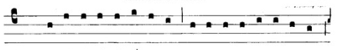
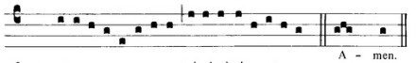

Before the ending of the day,
Creator of the world we pray,
That with thy wonted favour thou
Wouldst be our guard and keeper now.

From all ill dreams defend our eyes,
From nightly fears and fantasies;
Tread underfoot our ghostly foe,
That no pollution we may know.

O Father, that we ask be done,
Through Jesus Christ, thine only Son;
Who, with the Holy Ghost and thee,
Doth live and reign eternally.

The Word of God

Psalmody

One or more of the following psalms may be used

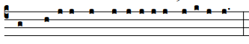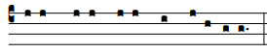

Psalm 31.1-6

1 In thee, O Lord, have I put my trust :
let me never be put to confusion, deliver me in thy righteousness.

2 Bow down thine ear to me :
make haste to deliver me.

3 And be thou my strong rock, and house of defence :
that thou mayest save me.

4 For thou art my strong rock, and my castle :
be thou also my guide, and lead me for thy name's sake.

5 Draw me out of the net, that they have laid privily for me :
for thou art my strength.

6 Into thy hands I commend my spirit :
for thou hast redeemed me, O Lord, thou God of truth.

Glory be to the Father, and to the Son :
and to the Holy Ghost;
as it was in the beginning, is now, and ever shall be :
world without end. Amen.

Scripture Reading

Thou, O Lord, art in the midst of us, and we are called by thy name; leave us not, O Lord our God.
Jeremiah 14.9
All Thanks be to God.

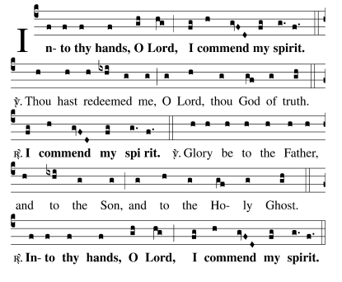

Gospel Canticle

The Nunc dimittis (The Song of Simeon) is said or sung

All Preserve us, O Lord, while waking,
and guard us while sleeping,
that awake we may watch with Christ,
and asleep we may rest in peace.

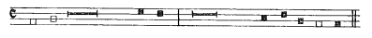

1 Lord, now lettest thou thy servant depart in peace :
according to thy word.

2 For mine eyes have seen :
thy salvation;

3 Which thou hast prepared :
before the face of all people;

4 To be a light to lighten the Gentiles :
and to be the glory of thy people Israel.
Luke 2.29-32
Glory be to the Father, and to the Son :
and to the Holy Ghost;
as it was in the beginning, is now, and ever shall be :
world without end. Amen.

All Preserve us, O Lord, while waking,
and guard us while sleeping,
that awake we may watch with Christ,
and asleep we may rest in peace.

Prayers

Lord, have mercy upon us.
All Christ, have mercy upon us.
Lord, have mercy upon us.

All Our Father, which art in heaven,
hallowed be thy name;
thy kingdom come;
thy will be done,
in earth as it is in heaven.
Give us this day our daily bread.
And forgive us our trespasses,
as we forgive them that trespass against us.
And lead us not into temptation;
but deliver us from evil. Amen.

Blessed art thou, Lord God of our fathers:
All to be praised and glorified above all for ever.

Let us bless the Father, the Son, and the Holy Ghost:
All let us praise him and magnify him for ever.

Blessed art thou, O Lord, in the firmament of heaven:
All to be praised and glorified above all for ever.

The almighty and most merciful Lord guard us and give us his blessing.
All Amen.

Wilt thou not turn again and quicken us;
All that thy people may rejoice in thee?

O Lord, shew thy mercy upon us;
All and grant us thy salvation.

Vouchsafe, O Lord, to keep us this night without sin;
All O Lord, have mercy upon us, have mercy upon us.

O Lord, hear our prayer;
All and let our cry come unto thee.

Let us pray.

One or more of the following Collects is said

Visit, we beseech thee, O Lord, this place,
and drive from it all the snares of the enemy;
let thy holy angels dwell herein to preserve us in peace;
and may thy blessing be upon us evermore;
through Jesus Christ our Lord.
All Amen.

Lighten our darkness, we beseech thee, O Lord;
and by thy great mercy defend us
from all perils and dangers of this night;
for the love of thy only Son, our Saviour, Jesus Christ.
All Amen.

O Lord Jesus Christ, son of the living God,
who at this evening hour didst rest in the sepulchre,
and didst thereby sanctify the grave
to be a bed of hope to thy people:
make us so to abound in sorrow for our sins,
which were the cause of thy passion,
that when our bodies lie in the dust,
our souls may live with thee;
who livest and reignest with the Father and the Holy Ghost,
one God, world without end.
All Amen.

Look down, O Lord, from thy heavenly throne,
illuminate the darkness of this night with thy celestial brightness,
and from the sons of light banish the deeds of darkness;
through Jesus Christ our Lord.
All Amen.

Be present, O merciful God,
and protect us through the silent hours of this night,
so that we who are wearied
by the changes and chances of this fleeting world,
may repose upon thy eternal changelessness;
through Jesus Christ our Lord.
All Amen.

The Conclusion

We will lay us down in peace and take our rest.
All For it is thou, Lord, only that makest us dwell in safety.

Abide with us, O Lord,
All for it is toward evening and the day is far spent.

As the watchmen look for the morning,
All so do we look for thee, O Christ.

The Lord be with you
All and with thy spirit.

Let us bless the Lord.
All Thanks be to God.

The almighty and merciful Lord,
the Father, the Son and the Holy Ghost,
bless us and preserve us.
All Amen.

